Background
Atmospheric CO₂ contains A LOT of information about sources and sinks, and has taught us much of what we know about one of the biggest stories in climate.
But as a field, we’re kind of stuck. There are at least a dozen research groups in the world using some variety of optimization methods to estimate the spatial and temporal patterns of net sources and sinks from atmospheric data. There’s vastly more data than 10 years ago, but we’re still quoting larger error bars for continental-scale annual fluxes than the bottom-up inventory people.
Worse, we don’t as a community have a very good strategy for understanding sources and sinks to enable better prediction of future carbon-climate feedback. Since the late 1980s and early 1990s, the basic idea hasn’t changed. We will make maps of carbon sources and sinks with progressively better resolution in space and time, and then interpret them in terms of mechanisms.
There’s also an idea in our field that “top-down” estimates of carbon budgets from atmospheric data should be kept separate from “bottom-up” methods based on upscaling local data with models, so that the two can be quantitatively compared against one another without mixing the two approaches. There are plenty of groups “keeping the data separate,” so there’s room for somebody to try mixing information from many sources, to try to get a better result.
Obviously, I need to write more here, but this is just a first draft.

Estimating Ecosystem GPP & Respiration by Inversion of CO₂ Data
Unlike most other efforts to estimate surface carbon budgets from variations in atmospheric CO₂, we seek to separately optimize gross fluxes due to photosynthesis (GPP), respiration (Resp), and air-sea gas exchange (Ocean). The framework we propose below is also generalizable to estimate fluxes from fossil fuel combustion (FF) and biomass burning (Fire). We separate the well-understood “fast” processes driven by environmental forcing (temperature, solar radiation, precipitation, wind speed) from “slow” processes driven by less-understood biases in biogeochemistry and emissions. The total flux of CO₂ to the atmosphere from any grid cell at any time can be written as:
where x denotes a spatial coordinate and t represents time, which is at hourly resolution. Here FF, Fire, RESP, GPP, and Ocean refer to the hourly gridded flux estimates described above. The β’s represent persistent multiplicative biases in the grid-scale component fluxes. A persistent bias in photosynthesis might result (for example) from underestimation of available nitrogen, leaf area, or agricultural fertilization, whereas a persistent bias in respiration might result from overestimation of litter, soil carbon or coarse woody debris. Sub-daily variations in the simulated component fluxes respiration and GPP are primarily controlled by the weather (especially changes in radiation due to clouds and the diurnal cycle of solar forcing), whereas seasonal changes are derived from phenological calculations parameterized from satellite imagery. Fine scale spatial variations are driven by changes in vegetation cover, soil texture, and soil moisture. It is reasonable to assume that the biases vary much more slowly than the fluxes themselves. Our method allows for component fluxes to vary on hourly, synoptic, and seasonal time scales, but assumes that biases in these fluxes persist over much longer periods.
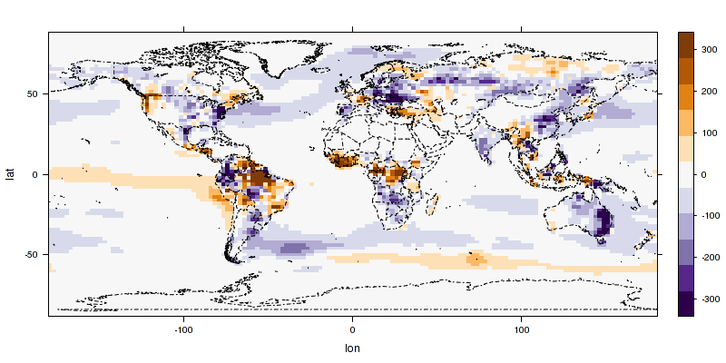
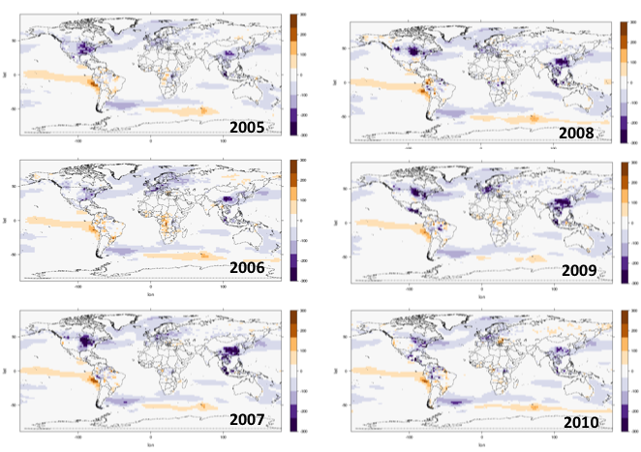
We have demonstrated the feasibility of this approach in observing system simulation experiments (OSSEs, using synthetic data) at both regional [Zupanski et al., 2007; Schuh et al., 2009] and global scales [Lokupitiya et al., 2008]. We calculated weekly GPP and RESP on a 100 km grid over most of North America in 2004 by applying this method to continuous CO₂ records from instrumented towers, and produced gridded maps of NEE that agree with other approaches[SCHUH et al., 2010]. The regional maps we derived highlight the sensitivity to lateral boundary conditions when considering limited areas of the planet, and error covariance between estimated GPP and RESP show that the uncertainty could be greatly reduced with independent information about gross component fluxes. Nevertheless, rigorous evaluation of various atmospheric inversion methods against detailed “bottom-up” inventory methods in the MidContinent Intensive region[Cooley et al., 2012], showed that our method performed extremely well at recovering both spatial and temporal variations at high resolution[Schuh et al., 2013].
GOSAT 2010
Figure 1: Annual net CO₂ flux to the atmosphere from terrestrial ecosystems and the ocean derived from in-situ measurements (top 6 panels) and from NASA ACOS b2.10 retrievals of GOSAT observations (right) by scaling GPP, RESP, and air-sea gas exchange using 200 ensemble members in the EnKF.
With previous NASA support, we have extended the analysis of gridded GPP and RESP to the global scale using an Ensemble Kalman Filter (EnKF, [Tippett et al., 2003]; [Peters et al., 2005; 2007]) with the GEOS-Chem atmospheric transport model [Bey et al., 2001]driven by 3D analyzed weather from the Modern Era Reanalysis (MERRA, [Rienecker et al., 2011]). Fig. 1 shows global variations of annual CO₂ fluxes estimated from 14-day b_{GPP} , b_{RESP}, and b_{Ocean} using the EnKF system to analyze in-situ measurements provided by NOAA (CarbonTracker 2011, http://carbontracker.noaa.gov). Also shown for comparison is a different estimate using precisely the same system to analyze GOSAT retrievals of column mean dry air mole fraction of CO₂ (NASA ACOS b2.10).
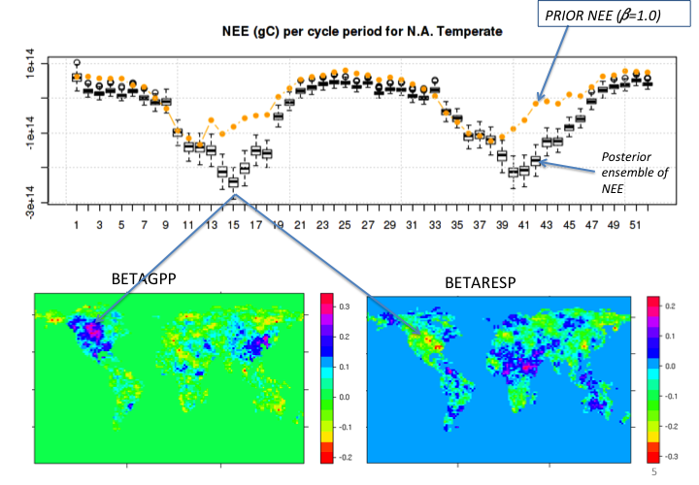
Prior estimates of terrestrial CO₂ fluxes were derived from hourly GPP and RESP simulated by the Simple Biosphere Model (SiB3, [Baker et al., 2010]) using b_{GPP} = b_{RESP} =1.0. The prior model has been evaluated at many eddy covariance sites around the world, with good skill on diurnal, synoptic, and seasonal time scales though like most steady-state carbon models the prior fluxes are annually balanced at every grid cell. Initial uncertainty in b_{GPP} and b_{RESP}, was set at s=0.2 at each grid cell, and a Gaussian PDF was sampled every 14 days to produce 200 ensemble members of candidate b’s. Each of these was used to drive a simulation of atmospheric CO₂ using GEOS-Chem driven by MERRA, and error statistics were computed for each ensemble member by sampling the resulting 3D CO₂ simulations at the time and location of each observation. At the end of each 14-day assimilation cycle, we solved for an optimal map of biases as well as an updated error covariance matrix. The optimized biases (b’s) were propagated from one assimilation cycle to the next (the last cycle’s estimate was the prior for the next cycle).
Figure 2: UPPER PANEL: Two annual cycles of net ecosystem exchange (NEE) of CO2 over temperate North America estimated by SiB3 ("Prior," orange dots), and by data assimilation using the EnKF (“Posterior,” black boxes and whiskers). Best estimate of 14-day NEE is indicated by the heavy bar, boxes contain the central 50% of the 200-member ensemble, and whiskers indicate the full range of possible values. LOWER PANEL: Maps of optimum estimates of biases b_{GPP} and b_{RESP} for the 15th assimilation cycle.

The ensemble system is completely flexible with respect to changes in the forward component models of ecosystems, oceans, and atmospheric transport, as well as being “embarrassingly parallel” and therefore well-adapted to large computer clusters or supercomputers. Error covariance was propagated (applying smoothing and inflation to prevent the estimates from collapsing to a tight prior), allowing quantitative estimation of uncertainty in derived quantities such as net flux (NEE) aggregated to any geographic region and time period [Lokupitiya et al., 2008; SCHUH et al., 2010]. As an example of the effect of data assimilation on estimates of NEE over an aggregated region, two annual cycles of 14-day results are shown for North America in Fig. 2. In each 14-day assimilation cycle, an optimum map of biases in the component fluxes GPP and RESP is computed from the ensemble of CO₂ errors, which we used to estimate continetal NEE. The assimilation systematically reduces wintertime respiration, deepens the summertime maximum drawdown of CO₂, and shifts this maximum later into the growing season relative to the (balanced) SiB3 prior.
Even in the absence of independent information about GPP and RESP, we have shown that the inclusion of mechanistic information about crop distributions, phenology, and physiology in the balanced SiB3 prior can produce very high fidelity estimates of NEE [Schuh et al., 2013]. Unfortunately, although the system we demonstrated here does produce maps of component fluxes, the optimization of multiplicative biases still doesn’t provide information about why the fluxes behave as they do.

Predictive Carbon Cycle Modeling with SiB4
Drilling down into carbon cycle mechanisms is the subject of this successor proposal. We propose to develop and evaluate a method to predict terrestrial carbon sources and sinks that result from the history of land-use and disturbance, from fertilization by anthropogenic CO₂ and nitrogen, and secular climate change. Each of these sources and sinks leaves signatures observed by a suite of NASA imagery and data. Fertilization increases leaf area, foliar nitrogen, and solar-induced chlorophyll fluorescence, depleting near-surface air of carbonyl sulfide (COS, [Berry et al., 2013b]). Forest regrowth and fire suppression affect aboveground biomass, which is observed by spaceborne LIDAR and RADAR instruments [Le Toan et al., 2011; Saatchi et al., 2011]. Climate variability and change produces observable changes in vegetation cover and phenology, observable by a variety of sensors. We seek to interpret these signatures using a mechanistic model of source and sink processes, quantifying the contribution of each to the contemporary carbon budget. Rather than simply estimating biases from CO₂ in the EnKF, we will use ensembles of a predictive model to find model states that are consistent with many different kinds of observations. The result will be a prototype assimilation system capable of analyzing mechansims that control the terrestrial carbon cycle, properly initialized with contemporary data to allow prediction of future carbon-climate feedback.
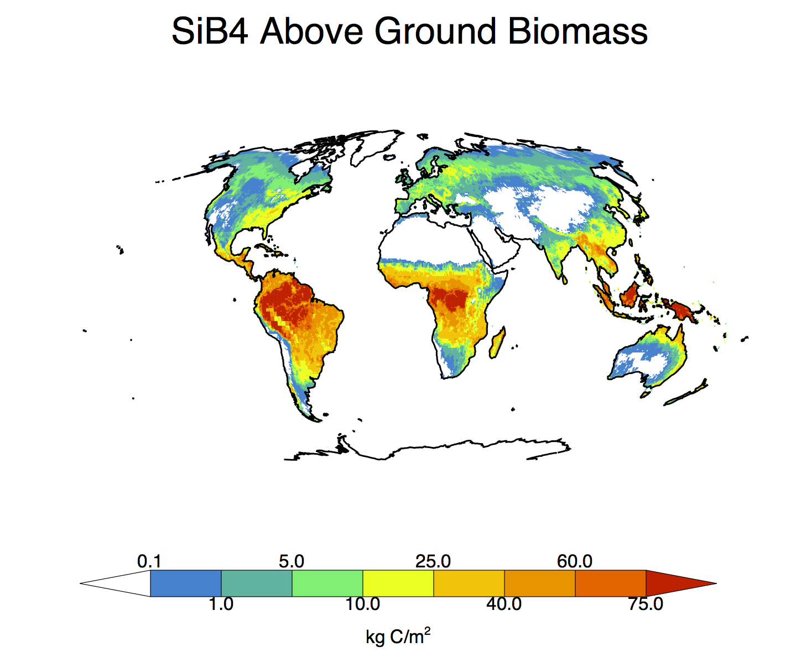
SiB4 combines a prognostic phenology model (SiBpp;[Stöckli et al., 2008; 2011]), a crop model (SiBcrop) [Lokupitiya et al., 2009; Corbin et al., 2010], and a terrestrial carbon pool model (SiB-CASA) [Schaefer et al., 2008]. We have also performed substantial model developments to create a fully prognostic system that uses minimal input data to simulate not only subhourly land-atmosphere exchanges of water, heat, and CO2, but also a suite of other observed ecological properties.
Predicted Leaf Area
Figure 3: Simulated aboveground biomass and leaf area index following initialization to steady state conditions
To create a self-consistent model, we integrated the prognostic phenology and carbon pool schemes. The previous prognostic phenology model, SiBpp, diagnosed the leaf area index (LAI) of vegetation using a combination of empirical temperature, moisture and light factors that were optimized to match satellite data; however, these estimates of LAI differed from the leaf pool calculated by the carbon pool model, SiB-CASA. Rather than simply prescribing the leaf pool to match the empirical LAI estimates, we modified SiB4 to utilize both the carbon stock data as well as the phonological factor information to create fully prognostic vegetation.
Combining the features of the previous separate models into a consistent modeling framework required substantial modifications to all three contributing components. In SiB4, carbon is stored in eleven different above and below ground carbon pools. Every time-step SiB4 computes the photosynthesis using enzyme kinetics ([Farquhar et al., 1980]) and stomatal physiology ([Collatz et al., 1991; 1992]), and it updates the carbon pools and resulting LAI daily. The carbon taken up via photosynthesis is allocated into storage (biomass) pools using environmental factors. The leaf allocation factors use the prognostic phenology algorithms, while the root and wood allocation fractions use algorithms described by Schaefer et al. (2007). The carbon released to the atmosphere via autotrophic and heterotrophic respiration is also calculated every time-step by applying prescribed turnover times, exchange coefficients, and environmental factors to the carbon pools. Using this flow of carbon allows the vegetation to vary not only with different plant functional types (PFTs), but also with different carbon stocks and different cli mate and weather conditions within a single PFT.
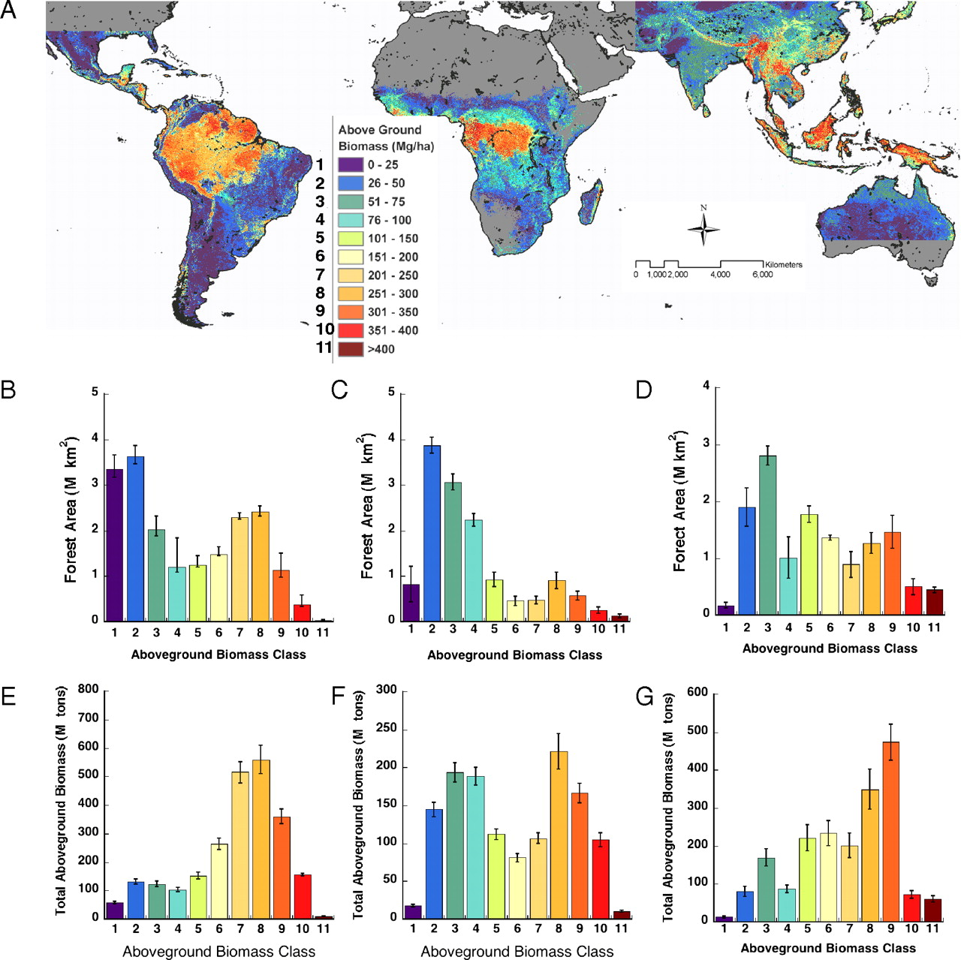
Incorporating carbon stocks and prognostic phenology into SiB4 increased the number of simulated ecological processes while reducing the amount of a priori data required, which not only helps us expand our understanding of the biosphere and resulting land-atmosphere exchanges, but also allows us to evaluate the model using a variety of different metrics. Deciduous plant functional types include predictions of LAI, leaf out and senescence timing, and the length of the growing season. Forests include estimates of tree and litter biomass. Agricultural crops (maize, soybean, and wheat) include predictions of planting date, growth, yield, and harvest. These properties can be compared against various data sets: above- and below- ground biomass and carbon stocks from field campaigns; carbon fluxes from chambers and flux towers; and remotely sensed tree height, wood pools, biomass density, and leaf area index (LAI).
Figure 4: Left) SiB4 simulated above ground biomass (Mg C/ha). Right) Above ground biomass from Saatchi et al (2011) using a combination of in situ inventory plots and satellite data.
In addition to developing the model, this past year we have begun evaluating the performance of SiB4. One metric to evaluate is the above ground biomass, which can be compared against remotely sensed satellite data. We compared simulated tropical forest above ground biomass (evergreen forest only) to estimates from [Saatchi et al., 2011] as shown in Fig. 4. The simulated biomass has similar magnitudes as the data, along with a similar spatial distribution; however, SiB4 has lower biomass estimates in the central basin and along the southeast coast.
Along with using satellite data, we also compared SiB4 results to field campaign measurements. Looking at three sites in South America, both carbon stocks and carbon fluxes can be compared to field data collected in the Large-Scale Biosphere-Atmosphere Experiment in the Amazon (LBA). SiB4 simulates the carbon pools quite well; however, it underestimates the differences between the two sites. Looking at the carbon fluxes, SiB4 again performs well: the observations show larger between-site differences which the model does a better job of capturing; however, SiB4 tends to underestimate the gross carbon uptake (GPP).
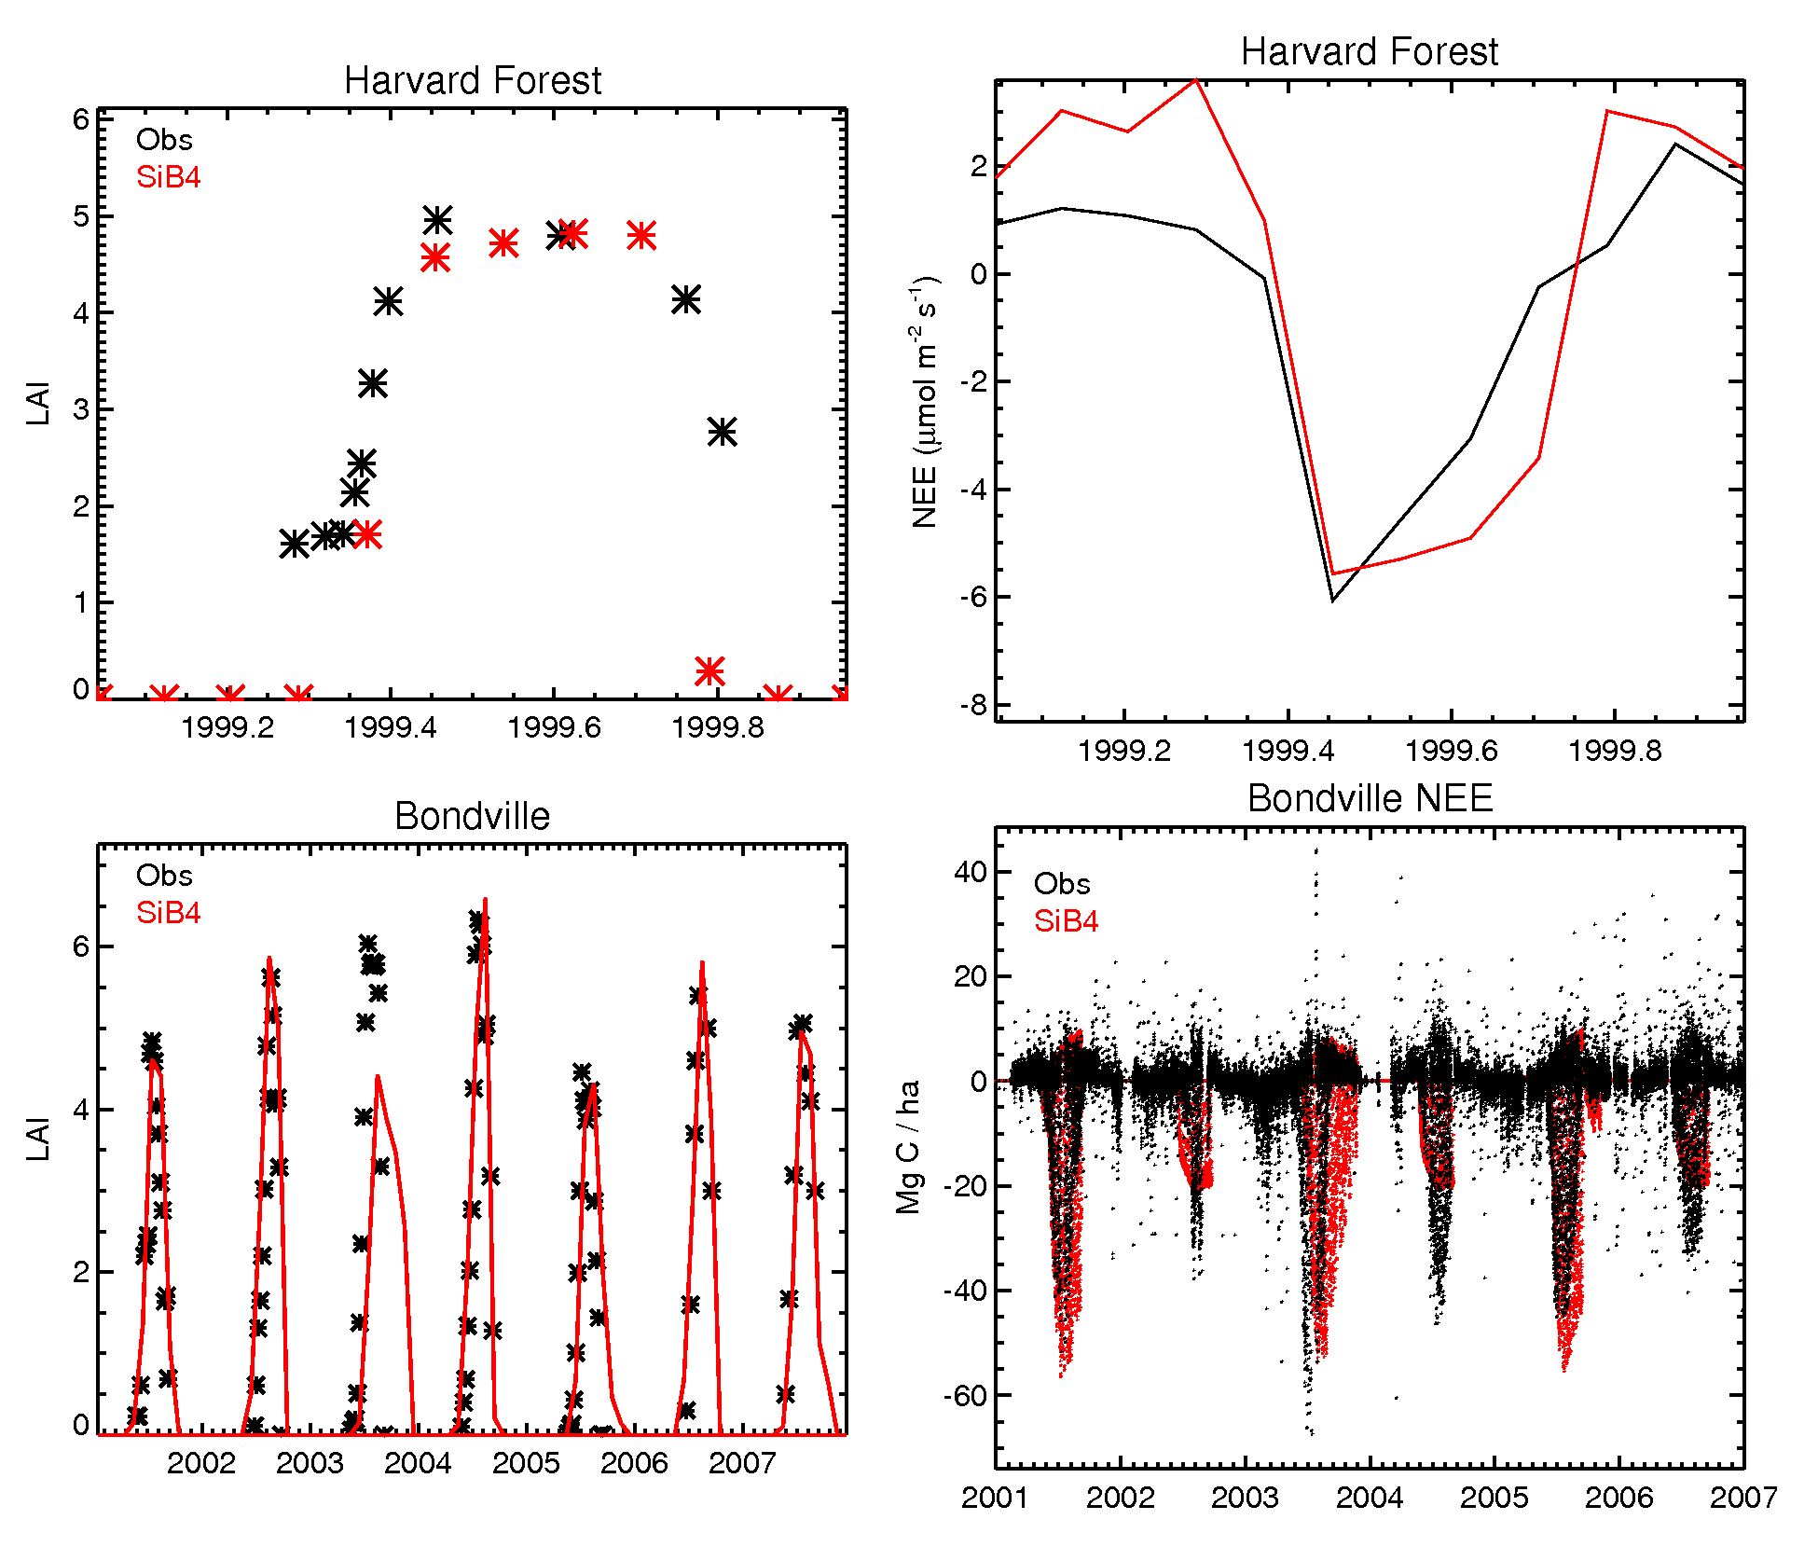
We compared SiB4 results to measurements at two flux tower sites in the United States: Harvard Forest, a deciduous forest in Massachusetts, and Bondville, an agricultural site in Illinois that alternates between maize (odd years) and soybeans (even years). Figure 6 shows the leaf area index (LAI) and net ecosystem exchange (NEE) comparisons at both sites. At Harvard Forest in 1999, the LAI simulated by SiB4 matches the observations well, capturing the timing of leaf out, the magnitude of the LAI during the summer, and the timing of senescence. The resulting monthly fluxes do not match as well: while the maximum drawdown is similar between the model and the observations, SiB4 overestimates the winter respiration as well as the uptake the second half of the growing season. Looking at multiple years at the Bondville site, the growing season for both maize and soybeans is very short but intense, and SiB4 captures this behavior well. The magnitude of the LAI has inter-annual variability, which also is simulated by SiB4, although the LAI is underestimated in 2003. Crops have significant drawdown during their short growing season, which is shown both in the observations and in the model. Maize has a stronger drawdown, while soybeans have a longer growing season, and SiB4 captures these traits.
Figure 6: Top left) Leaf area index (LAI) at Harvard Forest. Observations are in black and SiB4 results are red. Top Right) Monthly net ecosystem exchange (NEE, in μmol/m²/s) at Harvard Forest. Bottom left) LAI at Bondville. Bottom right) Hourly NEE at Bondville.
Figure 5: Left) Carbon stocks at three sites in the central Brazilian Amazon (K34, K67, and CAX). The stocks starting from the left are canopy, wood, coarse woody debris (CWD), litter, coarse root, fine root and soil pools. Black symbols show field measurements and red symbols show the SiB4 results. Right) Annual carbon fluxes (gross primary production, GPP; net primary production, NPP; autotrophic respiration, Rauto; heterotrophic respiration, Rhet; and ecosystem respiration, Reco).

Solar-Induced Fluorescence
Photons absorbed by leaves can follow one of three pathways: they can be utilized in the photosynthetic process, whereby the energy from the photon is used to break chemical bonds in CO2 and water to create sugars in photosystems 1 and 2 (PSI, PSII), the energy can be released as nonphotochemical quenching (NPQ; heat), or a small amount, generally about 1%, can be re-emitted as light from chlorophyll (Solar-Induced Fluorescence; SIF).
It has been shown that fluorescence yield (Φ_{f}) correlates with photosynthetic yield (Φ_{p}) when plants are exposed to stress in the form of drought or extreme temperature ([Flexas et al., 2002; Daumard et al., 2010]). Frequently, these stresses are expressed as changes in GPP and/or SIF almost immediately, while changes in canopy-scale physiology (i.e. LAI, fPAR) will take much longer to be realized[Berry et al., 2013a].
We can exploit the relationship between Φ_{p} and Φ_{p} to calculate SIF. SiB parameterizes photosynthesis through the use of enzyme kinetics originally developed by [Farquhar et al., 1980]. GPP is rate-limited to the minimum of light, carboxylation, and electron transport, and therefore linked stomatal conductance and the energy budget following [Collatz et al., 1991; 1992; Sellers et al., 1992a; 1992b].
The fluorescent yield ϕ_{f} in photosystem II (PSII) can be expressed as a function of rate constants for fluorescence (k_{f}), thermal deactivation (k_{D}), photosynthesis (k_{P}), and NPQ (k_{NPQ}) as follows
ϕ_{f}(PSII) = k_{f} / (k_{f} + k_{D} + k_{P} + k_{NPQ})
Within SiB we calculate the photochemical yield below the light limited rate, as
x = ϕPSII/ϕPSII₀
and it has been show that there is a relationship between the x and k_{NPQ} and k_{P} (Figure 7). We can use this relationship to link SIF to simulated photosynthesis in SiB, which has a proven track record. It would also be possible to use a purely empirical fit of fluorescence to photochemical yield using the curve shown in the right panel of Figure 7, but we prefer to use the method based on first principles.
Figure 7: (Left panel) Rate coefficients for photosynthesis and non-photochemical quenching vs. normalized photochemical yield; and (right panel) fluorescence vs. photochemical yield, measured and simulated using enzyme kinetics and electron transport in SiB. Figure from Berry et al (2013)
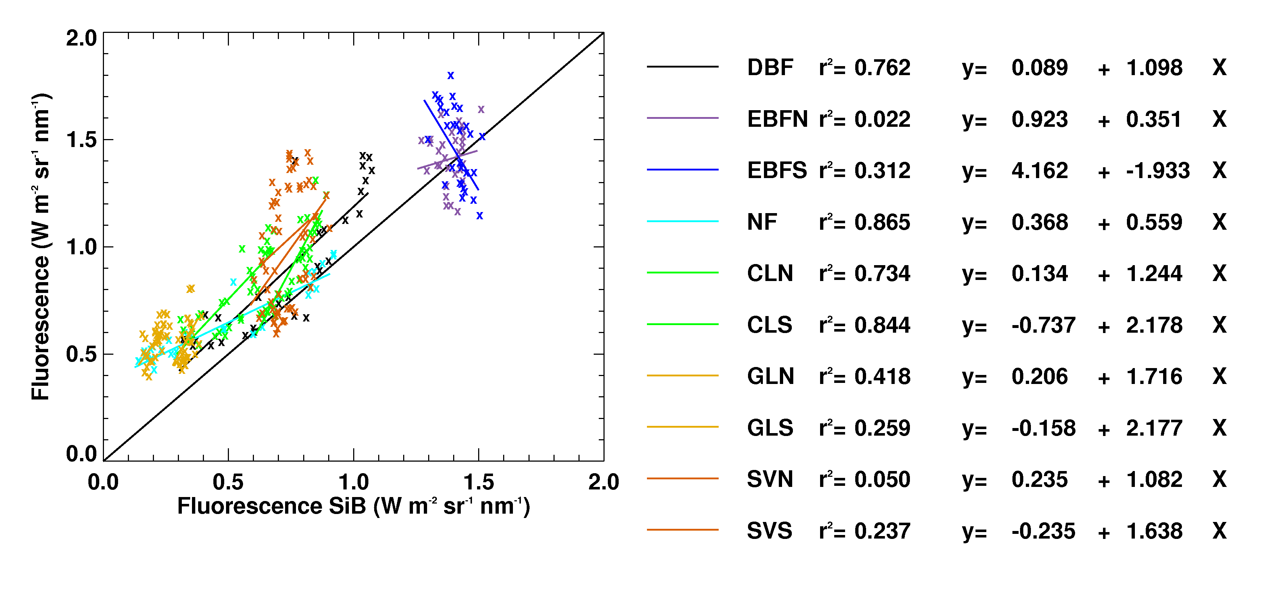
Using the formulation outlined above, we can calculate SIF within SiB and compare it to SIF obtained from GOSAT (Christian Frankenberg, personal communication). As an example, we aggregate simulated and observed SIF to obtain monthly values on a by-biome level for the GOSAT era (Figure 8; analogous to Figure 11 in [Guanter et al., 2012]).
Figure 8: Monthly mean SIF simulated in SiB (x-axis) vs retrieved from GOSAT (y-axis), aggregated by biome. GOSAT data provided by C. Frankenberg (pers. comm.)

Carbonyl Sulfide
Like solar-induced fluorescence, the atmospheric concentration of Carbonyl Sulfide (COS) contains independent information about GPP, separate from total respiration or NEE[Campbell et al., 2008; Blonquist et al., 2011]. COS is an atmospheric trace gas, a sulfur analog of CO₂ but about a million times less abundant[Montzka et al., 2007]. Like CO₂, it is taken up inside the stomata of photosynthesizing plants (by the enzyme carbonic anhydrase)[Sandoval-Soto et al., 2005; WOHLFAHRT et al., 2011]. Unlike CO₂ however, there is no analog to respiration returning COS to the atmosphere. Tropospheric concentrations of COS are drawn down like CO₂ during the Northern Hemisphere growing season, but decline by about 30% each summer, compared to a drawdown of about 6% for CO₂[Campbell et al., 2008; Suntharalingam et al., 2008].
We have developed and tested a parameterization for prediction of uptake of COS by vegetation and soils in SiB[Berry et al., 2013b]. The transport of COS from the free troposphere downward into vegetation canopies, through leaf laminar boundary layers, and into stomatal cavities therefore follows an identical pathway to that of CO₂. The model also accounts for a sink of COS in organic soils that contain residual carbonic anhydrase[Seibt et al., 2006; Van Diest and Kesselmeier, 2008]. Simulated uptake rates of COS agree well with leaf gas exchange measurements (Fig 9, [Stimler et al., 2010; 2012]).
Figure 9: Simulated and observed fluxes of CO₂ (top) and COS (bottom) in C3 and C4 plants (Figure from Berry et al, 2013)
COS is analyzed on a subset of samples collected from the NOAA ESRL flask network. To predict atmospheric COS as observed in these samples, [Berry et al., 2013b] also introduced emissions from biomass burning, anthropogenic sources, and the oceans, and included a chemical sink, and then introduce these sources and sinks into a global atmospheric tracer transport model. Simulated seasonal cycles are consistent with widely distributed observations and reveal the influence of GPP on global scales (Fig 10). The strong terrestrial drawdown must be balanced by an equal source, which was hypothesized to result from photochemical processes in the tropical oceans[Cutter et al., 2004].
Figure 10: Concentrations of COS at 12 monitoring stations over a three year period observed by NOAA ESRL and as simulated using SiB. Figure from Berry et al (2013b)

Model Initialization
Like other models of carbon stocks and fluxes, SiB4 can be initialized offline by solving the mass balance equation for each biomass and soil carbon pool assuming steady state between production and respiration or decomposition[Carvalhais et al., 2008]. This procedure always yields a solution in which terrestrial carbon sources and sinks are in balance at every grid cell, which is inconsistent with the fact that terrestrial GPP has exceeded RESP for decades. The terrestrial carbon sink is currently less than 3% of GPP. Mapping this sink in space and time is of course the objective of much of inverse modeling of atmospheric CO₂, but we propose instead to simulate terrestrial imbalances from mechanistic forcing. The mechanisms we propose to simulate are (1) the transient imbalance due to changes in land use and disturbance; (2) stimulation of GPP by rising atmospheric CO₂, with the resulting enhancement of decomposition delayed by the residence time of carbon in biomass and soils; (3) stimulation of GPP by nitrogen deposition; and (4) changes in GPP and RESP due to variations and secular changes in climate.
Starting from a balanced biosphere in steady state, we propose to simulate GPP, allocation of carbon to leaves, wood, and roots with cascading pools over the years 1700-2000 using forcing data derived for the Multi-scale Synthesis and Terrestrial Model Intercomparison Project (MsTMIP). These drivers include land use transitions, CO₂, nitrogen deposition, and climate, and we will perform the simulations using SiB4 on a 0.5 degree global grid.
These initialization experiments will be conducted in close collaboration with Deborah Huntzinger at Northern Arizona University and Anna Michalak at the Carnegie Institution of Washington (representing MsTMIP), and wih George Hurtt at the University of Maryland (representing the estimates of historical land use change).
From 1979 through the present, we will re-run the model using MERRA with adjustments to precipitation from GPCP. Starting in 2000, we will use the Global Fire Emissions Database {Mu:2011fs} to “burn off” aboveground carbon pools and allow for regrowth. This will allow the model to be updated to within a few months of real time to maximize our opportunity to evaluate and optimize against very recent observations (GOSAT, OCO2).
[Some words here about vegetation in 1700, climate 1700-1900]

Evaluation
The 300-year simulations with SiB4 will be analyzed carefully. We will compare our simulations of changes in biomass and soil carbon with similar calculations performed by Collaborator George Hurtt using the Ecosystem Demography (ED) model. Each model will also be compared with reconstructions of multicentury atmospheric CO₂ using the fossil fuel emissions record and uptake by the oceans(references). We will also work closely with Deborah Huntzinger and the MsTMIP community to compare, contrast, analyze and understand similarities and differences in simulated sources and sinks vis-à-vis other participating models. We will submit our simulations to the MsTMIP archive and participate in model benchmarking with the C-LAMP protocols.
In keeping with our objective of understanding the decadal imbalance between GPP and RESP as constrained by a broad suite of observations, we will focus evaluation on the controls of mean GPP and RESP on decadal time scales. Experimentation with SiB4 reveals that carbon pools with turnover times shorter than about a year simply adjust to changes in production, and that very recalcitrant pools like clay-bound carbon in soils are irrelevant to decadal changes. Evaluation of decadal respiration controls in SiB4 simulations will therefore focus on comparing aboveground biomass against LIDAR- and RADAR-derived estimates, and woody biomass against Forest Inventory Analysis. The objective will be to understand discrepancies in terms of underlying mechanisms. For example, if SiB4 systematically underpredicts biomass of tropical forests, we might suspect problems with the allocation of photosynthate, whereas if it overpredicts biomass of boreal forests we might suspect problems with mortality and turnover. Evaluation of decadal controls on GPP will focus on comparison of the amount and activity of photosynthesizing biomass. The density of active leaves will be assessed by comparing predicted LAI against MODIS data, and the intensity of mid-day GPP will be assessed by comparing simulated to observed solar-induced fluorescence.
Some adjustments to carbon allocation and turnover, nitrogen limitation, and phenology will almost certainly be necessary during the evaluation phase. Finally, we will use GEOS-Chem to simulate atmospheric CO₂ and COS from 2000-present using MERRA transport fields, GFED fire emissions, fossil fuel emissions, and air-sea gas exchange. These simulations will be compared in detail against observations made in-situ, from flask samples, from upward-looking spectrometers (TCCON), and from satellite platforms. We will further analyze patterns of spatial, seasonal, and interannual errors in the simulations, always with an eye toward mechanisms for decadal controls on GPP and RESP.

Uncertainty
Before attempting to optimize GPP and RESP, it is crucial that we develop consistent estimates of uncertainty and error covariance. We propose to use the model evaluation process described above to derive spatial patterns of slowly-varying controls on component fluxes: respiring biomass by comparison of SiB4 to LIDAR, RADAR, and FIA data; GPP by comparison of SiB4 to MODIS LAI/fPAR, and SIF from GOSAT and OCO2. Using these data, we will construct probability density functions (PDFs) of respiring biomass on decadal timescales (the sum of wood, structural litter, multiyear soil carbon, and coarse woody debris) and potential GPP (the product of fPAR and Vmax).
Estimates of uncertainty in GPP and RESP will then be derived using Monte Carlo methods by sampling these PDFs of potential GPP and RESP to create ensembles of simulations for a large number of eddy covariance sites that have already been used for synthesis studies (NACP, LBA, {SCHWALM:2010hf, Schaefer:2012cv} other refs). The ensembles will be augmented by using a variety of weather drivers (NCEP, MERRA, site meteorology) and then aggregated by vegetation type and latitude band so that hundreds of site-years can be aggregated into each bin for each month of the year. We will then compute root-mean-square fractional errors for simulated monthly GPP and RESP for each vegetation type in each latitude bin in each month of the year. These will then be scattered onto our global grid of vegetation types and multiplied by simulated GPP and RESP as estimates of uncertainty for each component flux at each location and time. We have already carried out a preliminary calculation using six different combinations of SiB drivers and parameters with 28 eddy covariance sites (Fig 11).

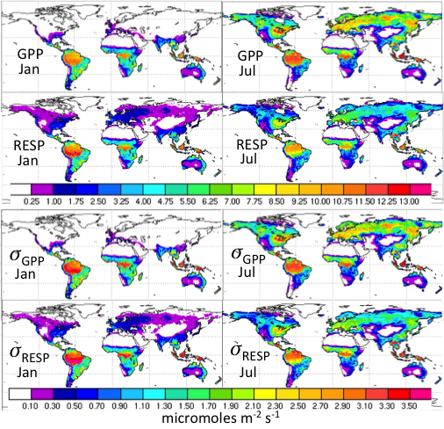
Figure 11: Simulated monthly mean GPP and RESP with uncertainties calculated from eddy covariance data as described in the text.

Optimization
We plan to experiment with several methods for optimization of state variables and parameters against a variety of data sources. Initially, we will simply use the improved forward model and the uncertainty analysis described above to specify better priors for the bias parameters b_{GPP} and b_{RESP} as described in Section 2. Ensembles of forward simulations of atmospheric CO₂ and COS will be sampled and compared to observations of COS from NOAA flasks and CO₂ from in-situ and remote instruments, and simulated SIF will be compared to observations from GOSAT and OCO2. Unlike our previous results, these assimilations will begin with priors that include carefully vetted mechanistic carbon sinks, and GPP will be separately constrained by independent data (COS and SIF). We will carefully analyze the resulting interannual maps of GPP, RESP, and NEE to interpret spatial patterns and interannual variations, focusing on sink mechanisms and climate variations.
In parallel with these efforts, we will experiment with simplified offline versions of the transport and observation operators (i.e., “toy” models). We will seek to define a robust control vector of combinations of variables that control long-term carbon sources and sinks and their interannual variations. These combinations would be adjusted in the EnKF instead of the arbitrary bias scalars b_{GPP} and b_{RESP}. We hypothesize that we can scale the sum of several carbon pools of intermediate turnover time, while preserving their relative sizes, in lieu of estimating b_{RESP}. Similarly, we hypothesize that the product of fPAR and Vmax can be scaled instead of b_{GPP}. Changes in these control variables would be semi-permanent, meaning that the new values would be updated by forward model logic in SiB. Error covariance would be updated as well, so that the control variables would adjust slowly to progressively more realistic values and new uncertainty would be calculated in each assimilation cycle. Deciding which combinations of control variable should be adjusted, how often, how freely, and how to handle error covariance in space and among variables will be difficult and time-consuming.
Finally, we hope to perform a prototype global assimilation of observed biomass, fluorescence, COS, and CO₂ using SiB4 and GEOS-Chem in the EnKF. The outcome will be a model that can (1) explain where, why, and how strong terrestrial carbon sources and sinks are in today’s world; (2) do so with detailed and defensible uncertainties based on quantitative comparison to observations; and (3) provide an initial state from which the future trajectories of sources, sinks, and carbon-climate feedback can be computed.

Management Plan

Personnel
Scott, Chris, Kathy, Andrew, PhD Student

Timeline
Year 1: Initialization
Year 2: Evaluation, Biomass & Flux uncertainties
Year 3: Optimization Experiments

Data Plan
Uncertainty & Error Covariance, both prior and posterior
Improved Priors & uncertainties for CMS & Others
Provision of source/sink layers as potential base layers for geostat inversion
Intercomparison
MsTMIP (Letter from DH)
ORNL DAAC (letter from BC)

References Cited
Baker, I. T., A. S. Denning, and R. STÖCKLI (2010), North American gross primary productivity: regional characterization and interannual variability, Tellus B, 62(5), 533–549, doi:10.1111/j.1600-0889.2010.00492.x. [online] Available from: http://onlinelibrary.wiley.com/doi/10.1111/j.1600-0889.2010.00492.x/full
Berry, J. A., C. Frankenberg, and P. Wennberg (2013a), New Methods for Measurements of Photosynthesis from Space, Workshop Report, Keck Institute for Space Studies, 1–72.
Berry, J. et al. (2013b), A Coupled Model of the Global Cycles of Carbonyl Sulfide and CO2: A Possible New Window on the Carbon Cycle, J. Geophys. Res. Biogeosci., n/a–n/a, doi:10.1002/jgrg.20068.
Bey, I., D. J. Jacob, R. M. Yantosca, J. A. Logan, B. D. Field, A. M. Fiore, Q. Li, H. Y. Liu, L. J. Mickley, and M. G. Schultz (2001), Global modeling of tropospheric chemistry with assimilated meteorology: Model description and evaluation, J. Geophys. Res., 106(D19), 23073–23–095.
Blonquist, J. M., Jr., S. A. Montzka, J. W. Munger, D. Yakir, A. R. Desai, D. Dragoni, T. J. Griffis, R. K. Monson, R. L. Scott, and D. R. Bowling (2011), The potential of carbonyl sulfide as a proxy for gross primary production at flux tower sites, J. Geophys. Res., 116(G4), G04019, doi:10.1029/2011JG001723.
Campbell, J. E., G. R. Carmichael, T. Chai, M. Mena-Carrasco, Y. Tang, D. R. Blake, N. J. Blake, S. A. Vay, G. J. Collatz, and I. Baker (2008), Photosynthetic control of atmospheric carbonyl sulfide during the growing season, SCIENCE-NEW YORK THEN WASHINGTON-, 322(5904), 1085–1088.
Carvalhais, N. et al. (2008), Implications of the carbon cycle steady state assumption for biogeochemical modeling performance and inverse parameter retrieval, Global Biogeochem. Cycles, 22(2), GB2007, doi:10.1029/2007GB003033.
Collatz, G. J., J. T. Ball, C. Grivet, and J. A. Berry (1991), Physiological and environmental regulation of stomatal conductance, photosynthesis and transpiration: a model that includes a laminar boundary layer, Agricultural and Forest Meteorology, 54(2), 107–136.
Collatz, G. J., M. Ribas-Carbo, and J. A. Berry (1992), Coupled photosynthesis-stomatal conductance model for leaves of C4 plants, Functional Plant Biology, 19(5), 519–538.
Cooley, D., F. J. Breidt, S. M. Ogle, A. E. Schuh, and T. Lauvaux (2012), A constrained least-squares approach to combine bottom-up and top-down CO2 flux estimates, Environ Ecol Stat, 20(1), 129–146, doi:10.1007/s10651-012-0211-6.
Corbin, K. D., A. S. Denning, E. Y. LOKUPITIYA, A. E. SCHUH, N. L. MILES, K. J. Davis, S. RICHARDSON, and I. T. Baker (2010), Assessing the impact of crops on regional CO2 fluxes and atmospheric concentrations, Tellus B, 62(5), 521–532, doi:10.1111/j.1600-0889.2010.00485.x.
Cutter, G. A., L. S. Cutter, and K. C. Filippino (2004), Sources and cycling of carbonyl sulfide in the Sargasso Sea, Limnology and oceanography, 49(2), 555–565.
Daumard, F., S. Champagne, A. Fournier, Y. Goulas, A. Ounis, J.-F. Hanocq, and I. Moya (2010), A Field Platform for Continuous Measurement of Canopy Fluorescence, IEEE Trans. Geosci. Remote Sensing, 48(9), 3358–3368, doi:10.1109/TGRS.2010.2046420.
Farquhar, G. D., S. V. von Caemmerer, and J. A. Berry (1980), A biochemical model of photosynthetic CO2 assimilation in leaves of C3 species, Planta, 149(1), 78–90.
Flexas, J., J. M. Escalona, S. Evain, J. Gulías, I. Moya, C. B. Osmond, and H. Medrano (2002), Steady‐state chlorophyll fluorescence (Fs) measurements as a tool to follow variations of net CO2 assimilation and stomatal conductance during water‐stress in C3 plants, Physiologia Plantarum, 114(2), 231–240.
Guanter, L., C. Frankenberg, A. Dudhia, P. E. Lewis, J. Gómez-Dans, A. Kuze, H. Suto, and R. G. Grainger (2012), Retrieval and global assessment of terrestrial chlorophyll fluorescence from GOSAT space measurements, Remote Sensing of Environment, 121, 236–251, doi:10.1016/j.rse.2012.02.006. [online] Available from: http://www.sciencedirect.com/science/article/pii/S0034425712000909
Le Toan, T. et al. (2011), The BIOMASS mission: Mapping global forest biomass to better understand the terrestrial carbon cycle, Remote Sensing of Environment, 115(11), 2850–2860, doi:10.1016/j.rse.2011.03.020.
Lokupitiya, E., S. Denning, K. Paustian, I. Baker, K. Schaefer, S. Verma, T. Meyers, C. Bernacchi, A. Suyker, and M. Fischer (2009), Incorporation of crop phenology in Simple Biosphere Model (SiBcrop) to improve land-atmosphere carbon exchanges from croplands, Biogeosciences, 6, 1–18.
Lokupitiya, R. S., D. Zupanski, A. S. Denning, S. R. Kawa, K. R. Gurney, and M. Zupanski (2008), Estimation of global CO 2fluxes at regional scale using the maximum likelihood ensemble filter, J. Geophys. Res., 113(D20), D20110, doi:10.1029/2007JD009679.
Montzka, S., P. Calvert, B. Hall, J. Elkins, T. Conway, P. Tans, and C. Sweeney (2007), On the global distribution, seasonality, and budget of atmospheric carbonyl sulfide (COS) and some similarities to CO2, J. Geophys. Res., 112, D09302.
Peters, W., A. R. Jacobson, C. Sweeney, A. E. Andrews, T. J. Conway, K. Masarie, J. B. Miller, L. M. P. Bruhwiler, G. Petron, and A. I. Hirsch (2007), An atmospheric perspective on North American carbon dioxide exchange: CarbonTracker, Proceedings of the National Academy of Sciences, 104(48), 18925.
Peters, W., J. B. Miller, J. Whitaker, A. S. Denning, A. Hirsch, M. C. Krol, D. Zupanski, L. Bruhwiler, and P. P. Tans (2005), An ensemble data assimilation system to estimate CO 2surface fluxes from atmospheric trace gas observations, J. Geophys. Res., 110(D24), doi:10.1029/2005JD006157.
Rienecker, M. M. et al. (2011), MERRA: NASA’s Modern-Era Retrospective Analysis for Research and Applications, J. Climate, 24(14), 3624–3648, doi:10.1175/JCLI-D-11-00015.1.
Saatchi, S. S. et al. (2011), Benchmark map of forest carbon stocks in tropical regions across three continents, Proceedings of the National Academy of Sciences, 108(24), 9899–9904, doi:10.1073/pnas.1019576108.
Sandoval-Soto, L., M. Stanimirov, M. Von Hobe, V. Schmitt, J. Valdes, A. Wild, and J. Kesselmeier (2005), Global uptake of carbonyl sulfide (COS) by terrestrial vegetation: Estimates corrected by deposition velocities normalized to the uptake of carbon dioxide (CO 2), Biogeosciences, 2(2), 125–132.
Schaefer, K., G. J. Collatz, P. Tans, A. S. Denning, I. Baker, J. Berry, L. Prihodko, N. Suits, and A. Philpott (2008), Combined Simple Biosphere/Carnegie-Ames-Stanford Approach terrestrial carbon cycle model, J. Geophys. Res., 113(G3), G03034, doi:10.1029/2007JG000603.
SCHUH, A. E., A. S. Denning, K. D. Corbin, I. T. Baker, M. Uliasz, N. Parazoo, A. E. Andrews, and D. E. J. Worthy (2010), A regional high-resolution carbon flux inversion of North America for 2004, Biogeosciences, 7(5), 1625–1644, doi:10.5194/bg-7-1625-2010.
Schuh, A. E., T. Lauvaux, T. O. West, A. S. Denning, K. J. Davis, N. Miles, S. Richardson, M. Uliasz, E. Lokupitiya, and D. Cooley (2013), Evaluating atmospheric CO2 inversions at multiple scales over a highly inventoried agricultural landscape, Global Change Biology, doi:10.1007/s10584-011-0153-2.
Schuh, A., A. Denning, M. Uliasz, and K. Corbin (2009), Seeing the forest through the trees: Recovering large-scale carbon flux biases in the midst of small-scale variability, J. Geophys. Res., 114, G03007.
Seibt, U., L. Wingate, J. Lloyd, and J. A. Berry (2006), Diurnally variable δ18O signatures of soil CO 2fluxes indicate carbonic anhydrase activity in a forest soil, J. Geophys. Res., 111(G4), G04005, doi:10.1029/2006JG000177.
Sellers, P. J., J. A. Berry, G. J. Collatz, C. B. Field, and F. G. Hall (1992a), Canopy reflectance, photosynthesis, and transpiration. III. A reanalysis using improved leaf models and a new canopy integration scheme, Remote Sensing of Environment, 42(3), 187–216.
Sellers, P. J., M. D. Heiser, and F. G. Hall (1992b), Relations between surface conductance and spectral vegetation indices at intermediate (100 m2 to 15 km2) length scales, Journal of Geophysical Research: Atmospheres (1984–2012), 97(D17), 19033–19059.
Stimler, K., J. A. Berry, and D. Yakir (2012), Effects of Carbonyl Sulfide and Carbonic Anhydrase on Stomatal Conductance, PLANT PHYSIOLOGY, 158(1), 524–530, doi:10.1104/pp.111.185926.
Stimler, K., S. A. Montzka, J. A. Berry, Y. Rudich, and D. Yakir (2010), Relationships between carbonyl sulfide (COS) and CO2 during leaf gas exchange, New Phytologist, 186(4), 869–878, doi:10.1111/j.1469-8137.2010.03218.x.
Stöckli, R., T. Rutishauser, D. Dragoni, J. O'Keefe, P. E. Thornton, M. Jolly, L. Lu, and A. S. Denning (2008), Remote sensing data assimilation for a prognostic phenology model, J. Geophys. Res., 113(G4), G04021, doi:10.1029/2008JG000781.
Stöckli, R., T. Rutishauser, I. Baker, M. A. Liniger, and A. S. Denning (2011), A global reanalysis of vegetation phenology, J. Geophys. Res., 116(G3), doi:10.1029/2010JG001545.
Suntharalingam, P., A. J. Kettle, S. M. Montzka, and D. J. Jacob (2008), Global 3-D model analysis of the seasonal cycle of atmospheric carbonyl sulfide: Implications for terrestrial vegetation uptake, Geophys. Res. Lett., 35(19), L19801, doi:10.1029/2008GL034332.
Tippett, M. K., J. L. Anderson, C. H. Bishop, T. M. Hamill, and J. S. Whitaker (2003), Ensemble square root filters*, Monthly weather review, 131(7), 1485–1490.
Van Diest, H., and J. Kesselmeier (2008), Soil atmosphere exchange of carbonyl sulfide (COS) regulated by diffusivity depending on water-filled pore space, Biogeosciences, 5(2), 475–483.
Wohlfahrt, G., F. Brilli, L. Hörtnagl, X. Xu, H. Bingemer, A. Hansel, And F. Loreto (2011), Carbonyl sulfide (COS) as a tracer for canopy photosynthesis, transpiration and stomatal conductance: potential and limitations†, Plant, Cell & Environment, 35(4), 657–667, doi:10.1111/j.1365-3040.2011.02451.x.
Zupanski, D., A. S. Denning, M. Uliasz, M. Zupanski, A. E. Schuh, P. J. Rayner, W. Peters, and K. D. Corbin (2007), Carbon flux bias estimation employing Maximum Likelihood Ensemble Filter (MLEF), J. Geophys. Res., 112(D17), doi:10.1029/2006JD008371.

